Docker- Cloud Technology



Why Docker:

Before Docker came to picture earlier we were using virtualization

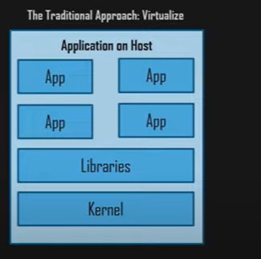

Here we weren’t using same os as host and guest. It leads to apps working in diff env but not in others.

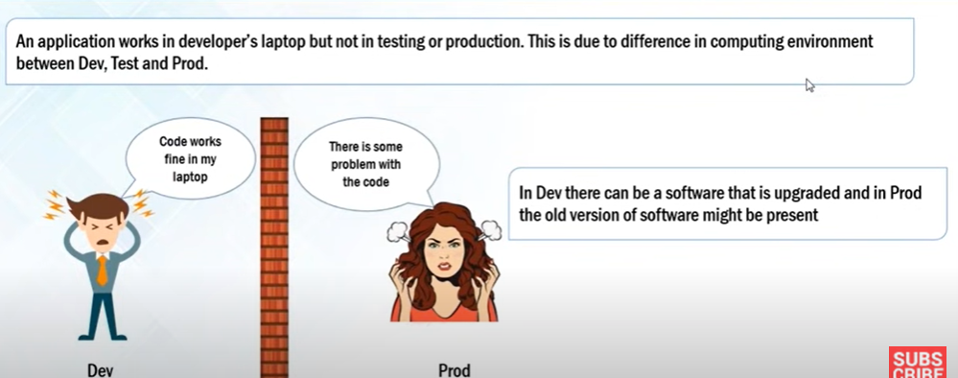

Pbm before Docker:

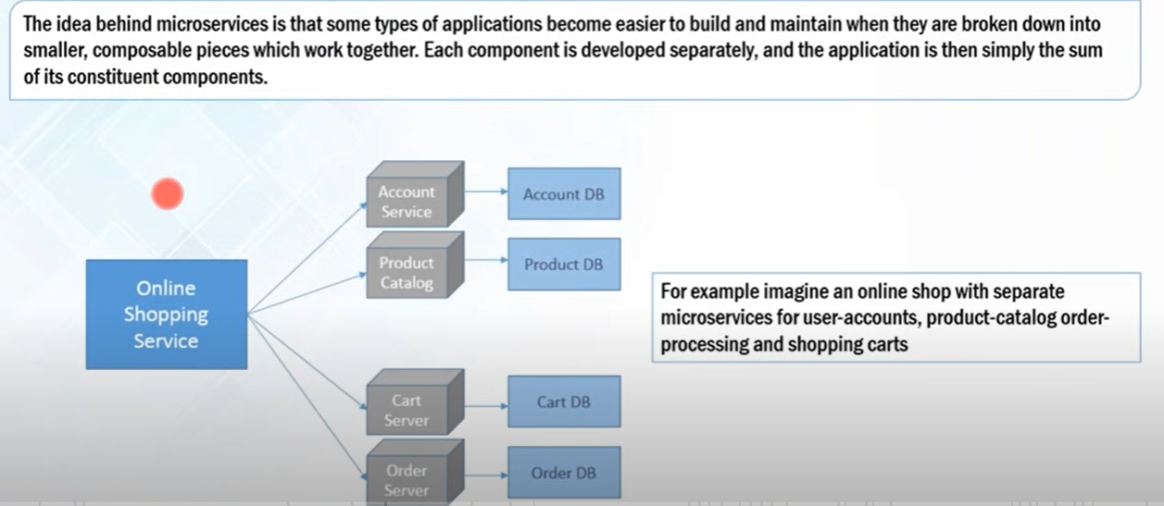

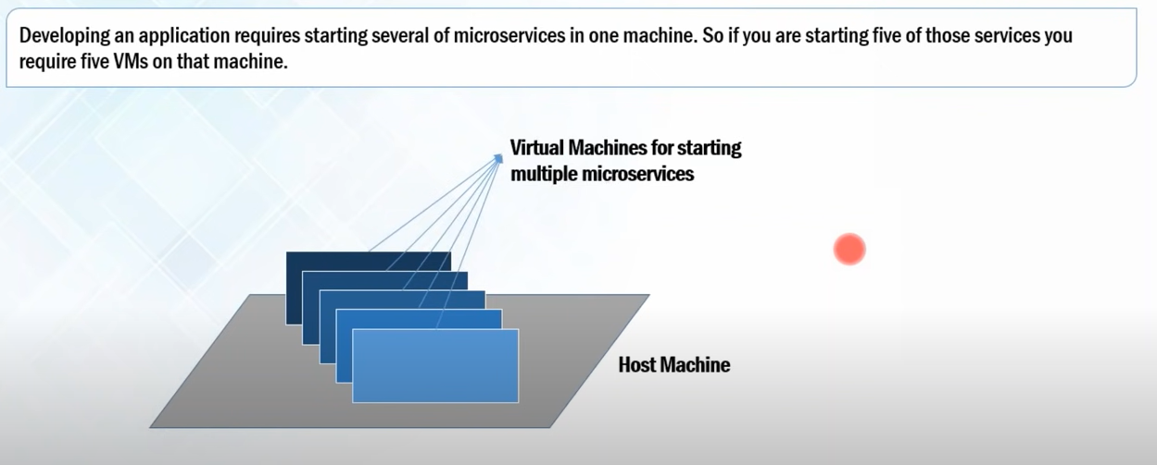

IN VM there is a lot of wastage of resources such as RAM, Processor, Disc Space are not utilized completely by micro services running in these vm’s.

If your app requires 50 micro services then using of VM is of no use, bcz of wastage of resources.

How Docker Solved these Problems:

Docker containers: DC are the lightweight alternatives of VM’s.

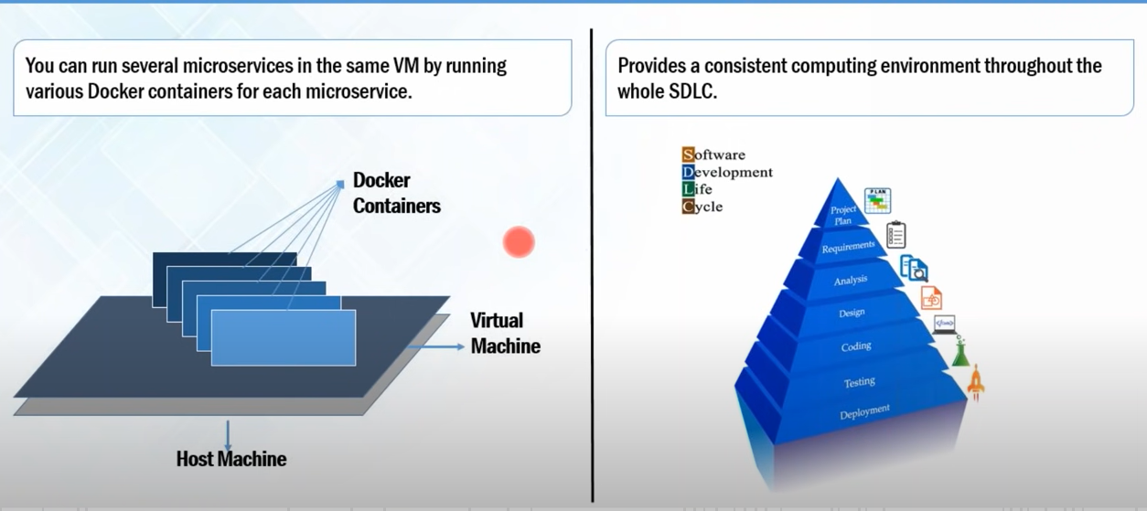

Here we no need to define the RAM and disc space it will take according to the requirement of applications.

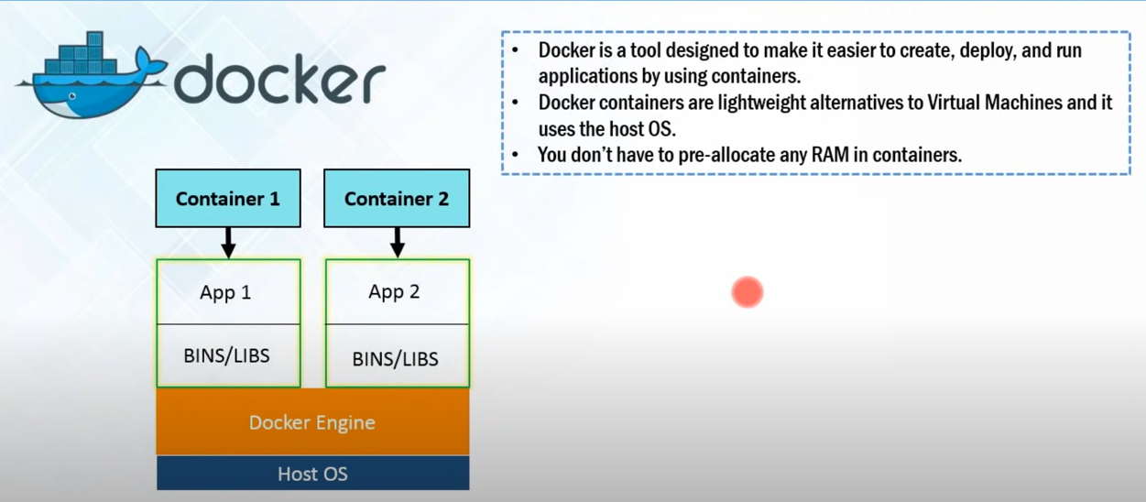

Docker Architecture:

Docker Hub: is a repo for Docker images.

Docker File: A Dockerfile is **a text document that contains all the commands a user could call on the command line to assemble an image**.

Docker image: A Docker image is **a read-only template that contains a set of instructions for creating a container that can run on the Docker platform.**

**Docker Container: Run time instance of docker image**

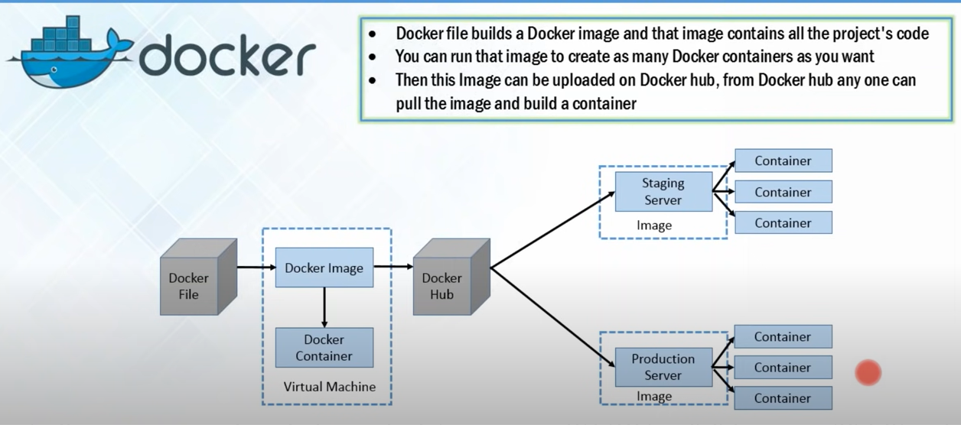

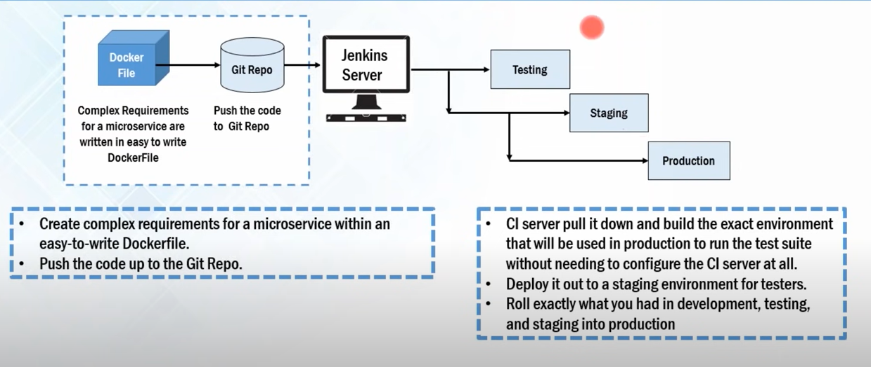

Docker Case study – Indiana university.

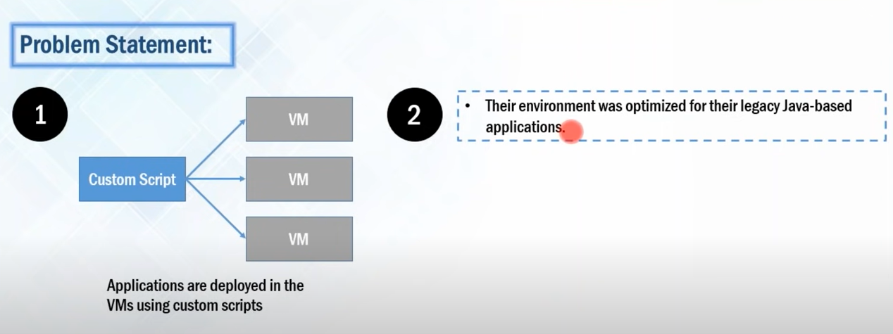

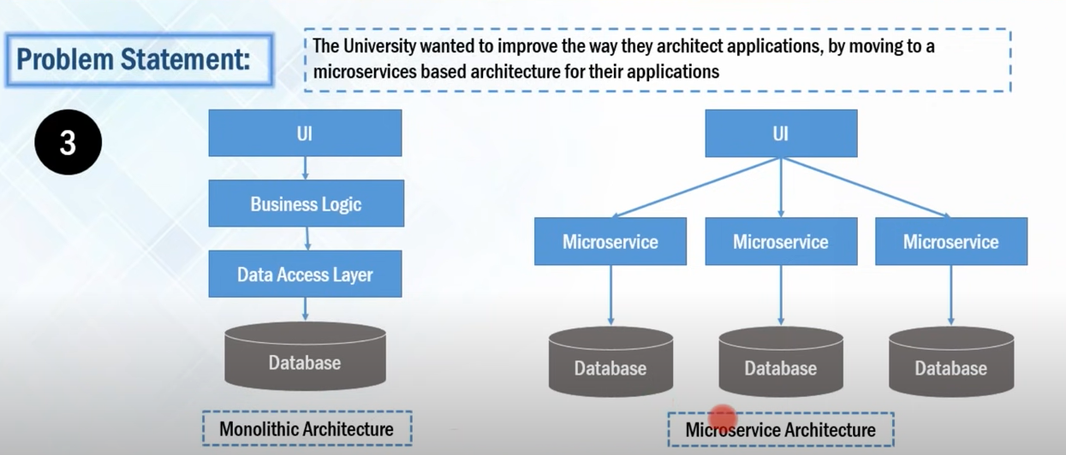

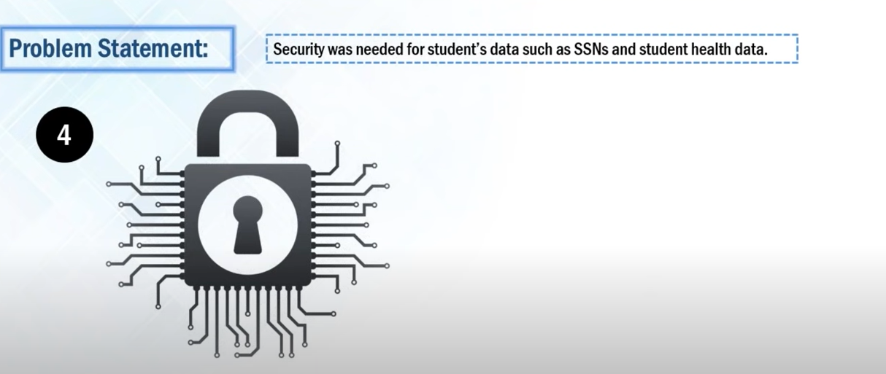

Solution is Docker Data Centre:

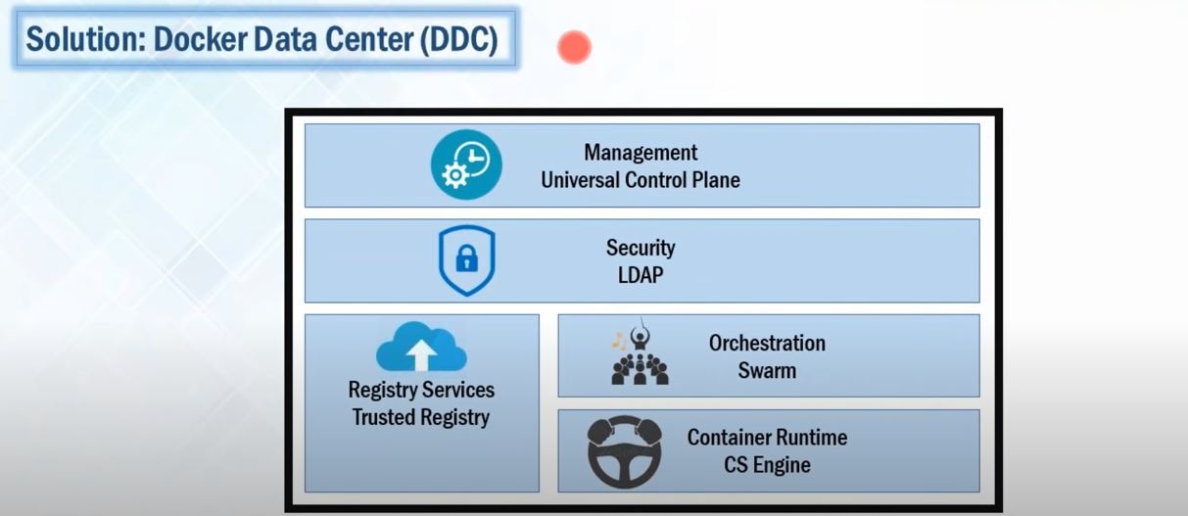

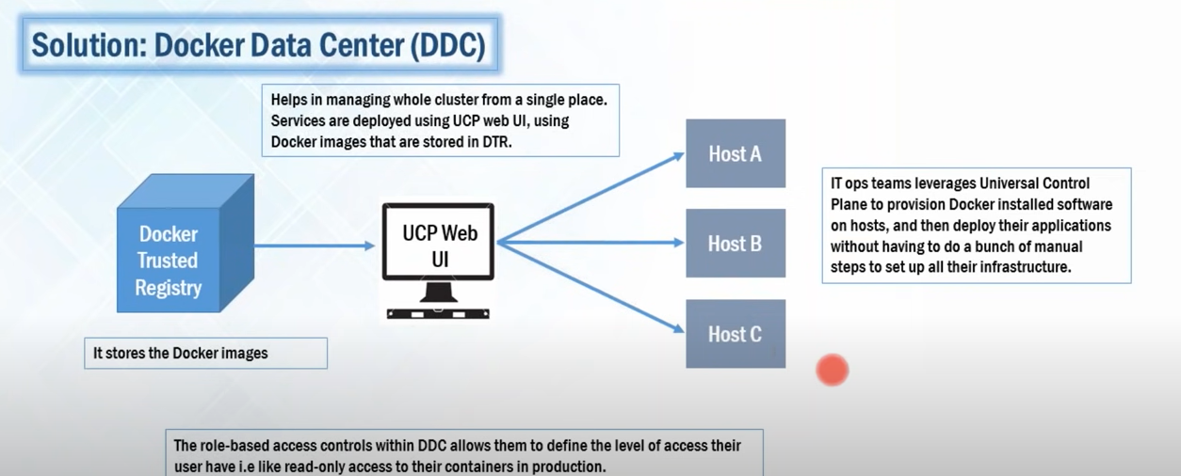

Here Security means – they can give RO access to prod and RW to Dev team.

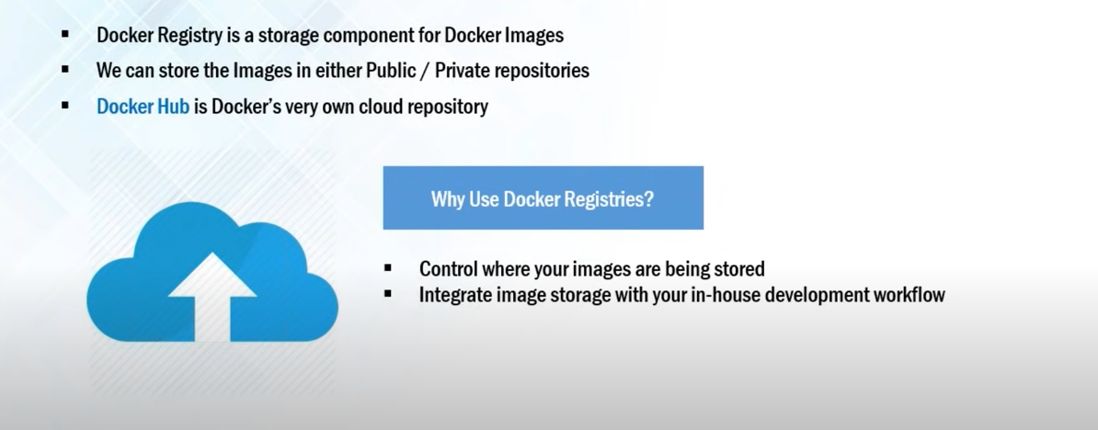

Ask them to Create your own docker repository.

Docker Image and Container:

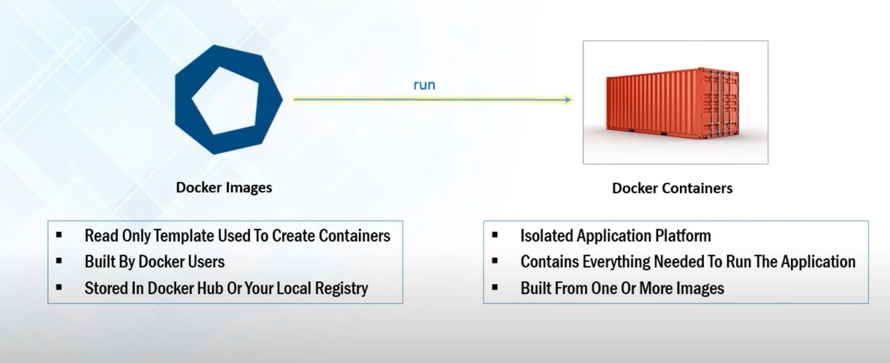

Docker Compose: Run multiple container as multiple service using single command.

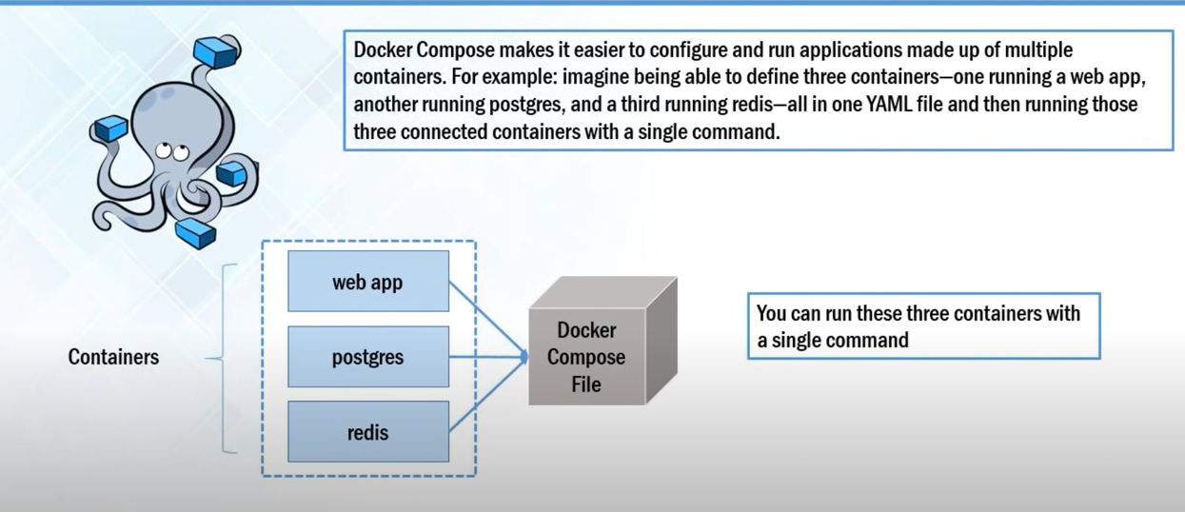

Explain Docker installation part:

Curl -fsSl https:// get.docker.com/ | sh 🡪 it add docker repo and install docker

First it will check the image present in local or not if its there then it will take it else it will download from repo(registry dockerhub.com)

DockerFile:

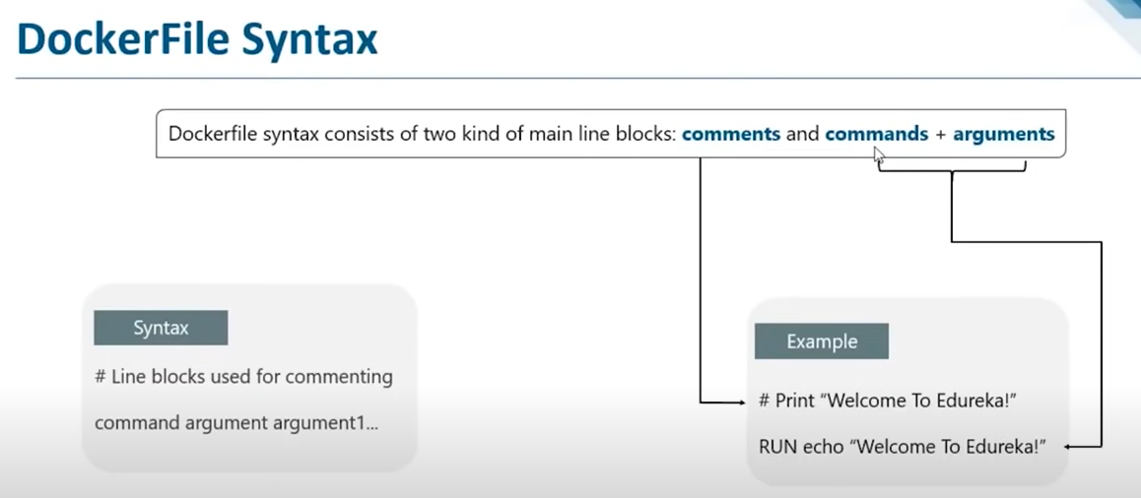

1. FROM:

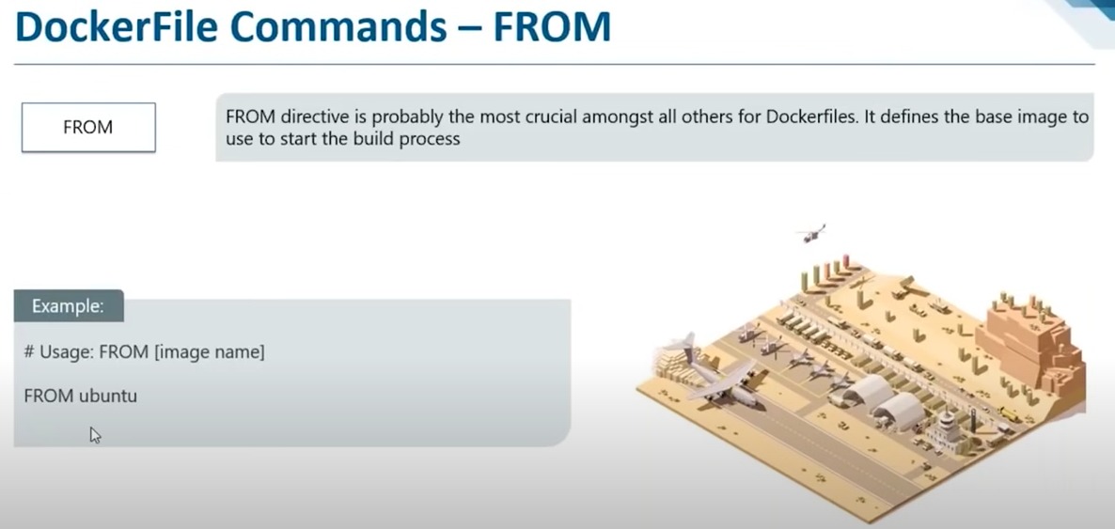

2.RUN:

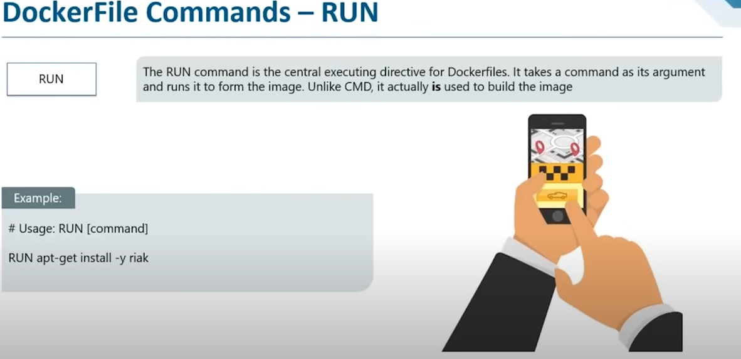

3.CMD:

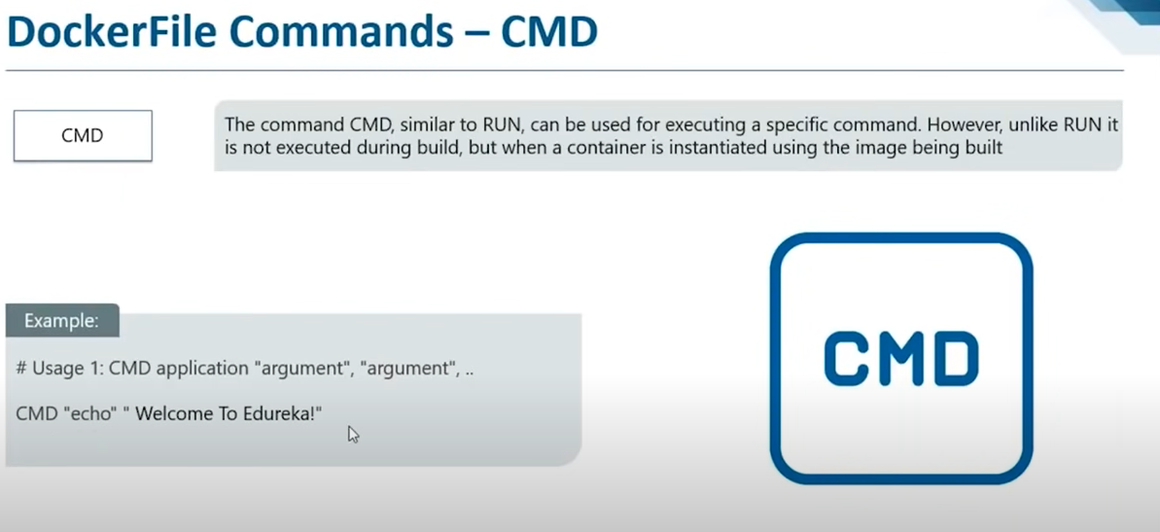

4. ENTRYPOINT:

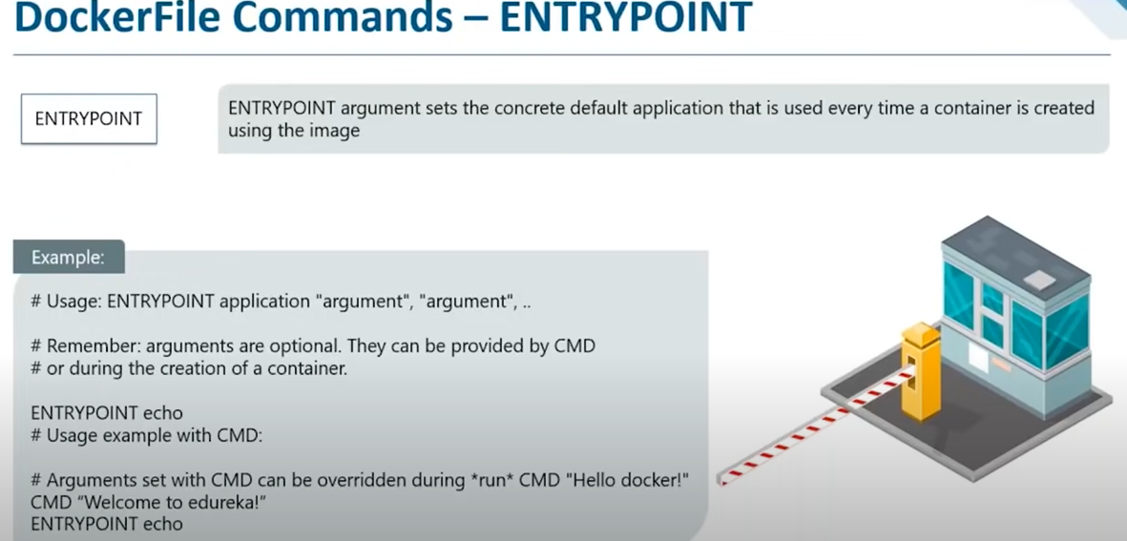

5. ADD:

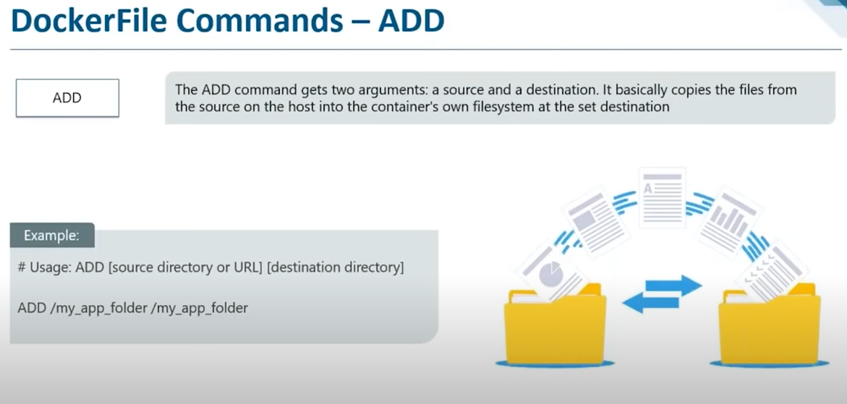

5. ENV

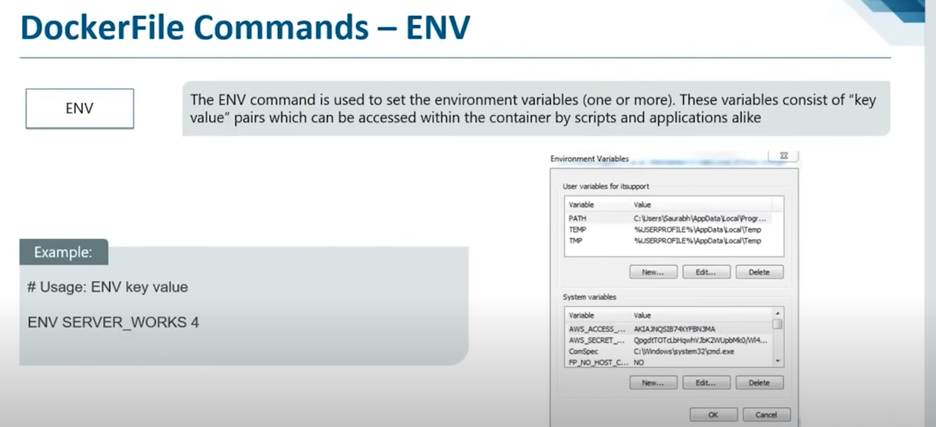

6. WORKDIR:

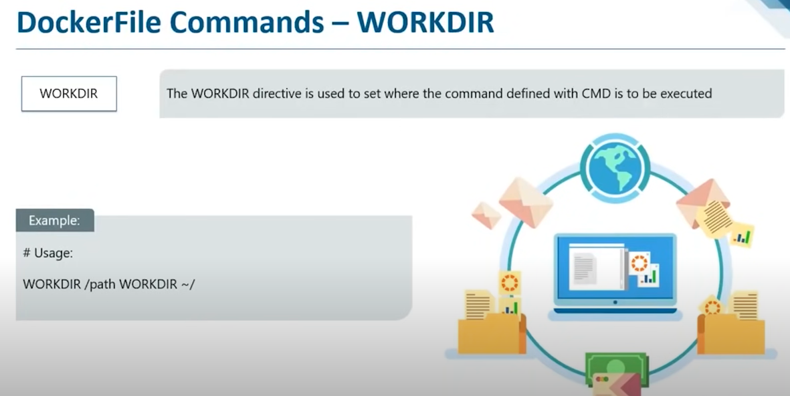

7. EXPOSE:

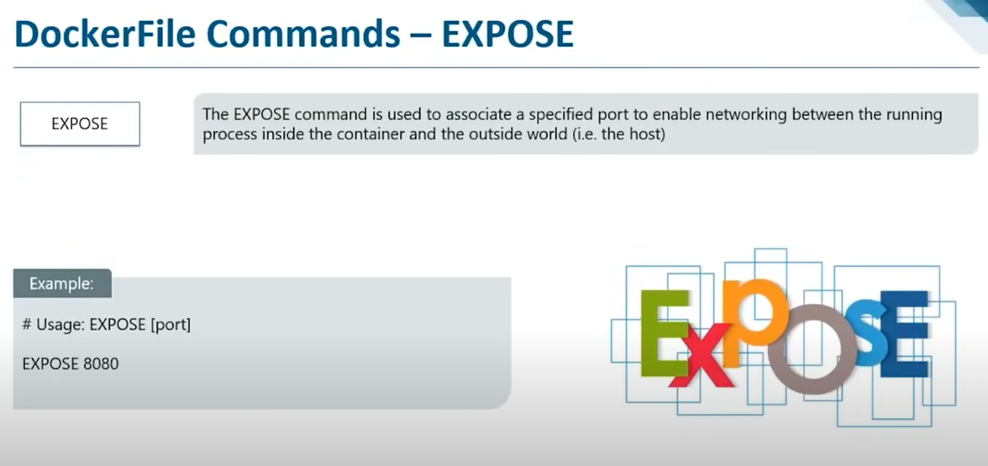

8. Maintainer:

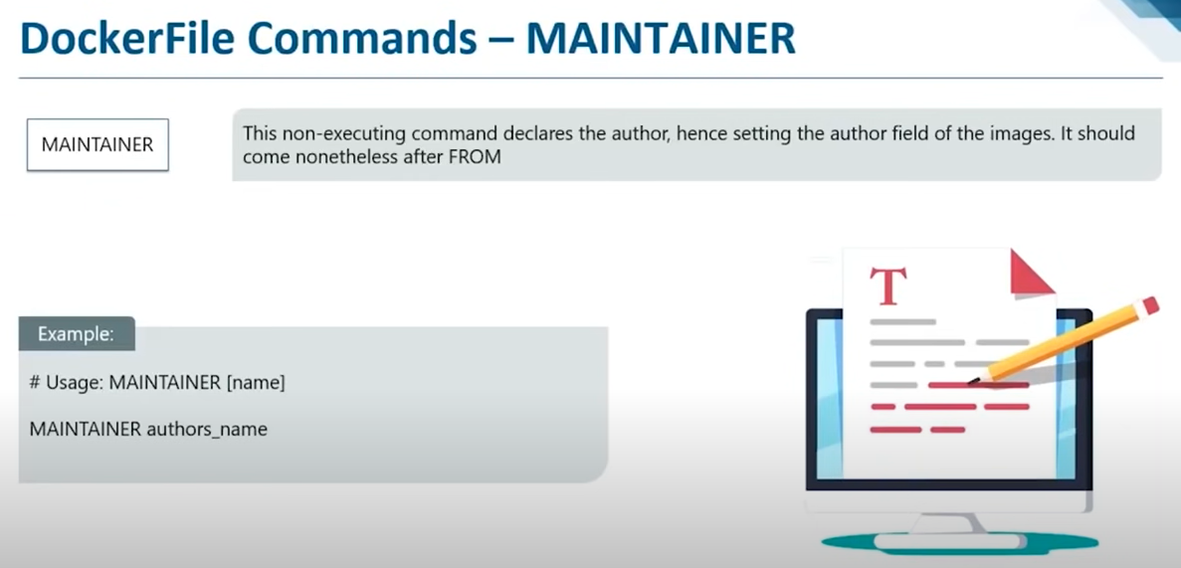

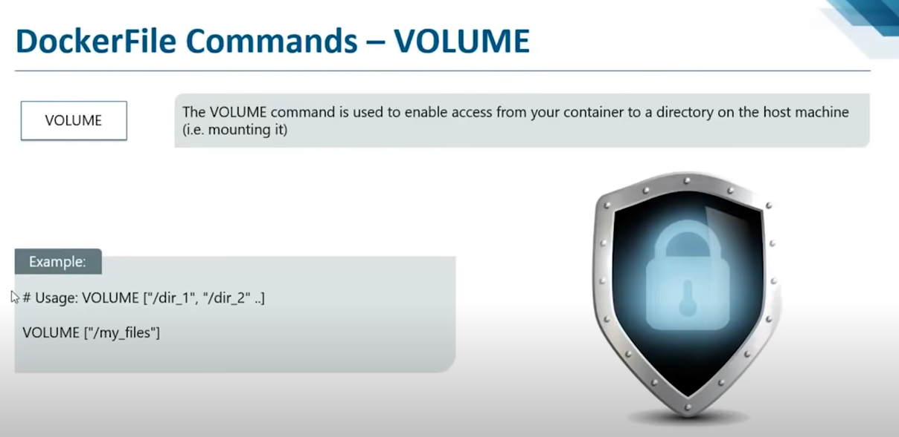

Creating An image to install Apache web server:

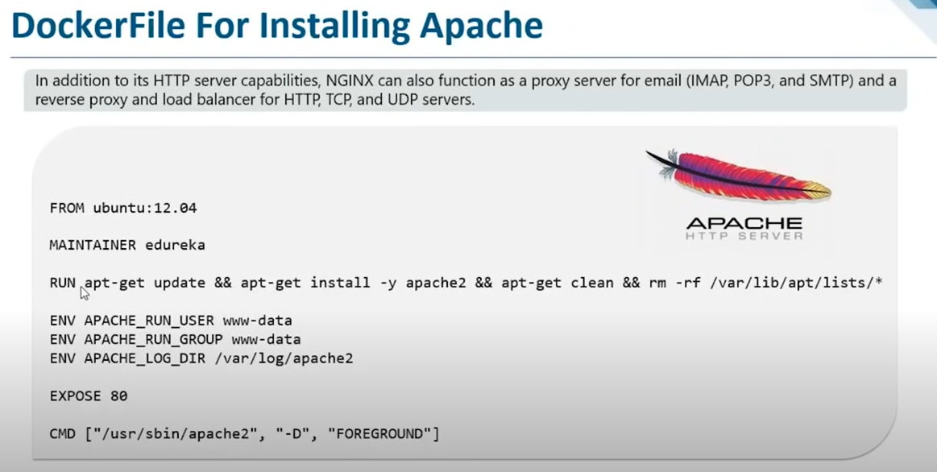

Cd Anvith

Ls

Cat Dockerfile

Sudo docker build -t myapacheimage . (dockefile present in this folder only)

It will build do docker images

Sudo docker run -p 80:80 (host:containerport) --name:App1 myapacheimage

Go in browser ip:80

To stop container do ctrl+c but this is not advisable do exit

Demo 2:

Installing NGINX

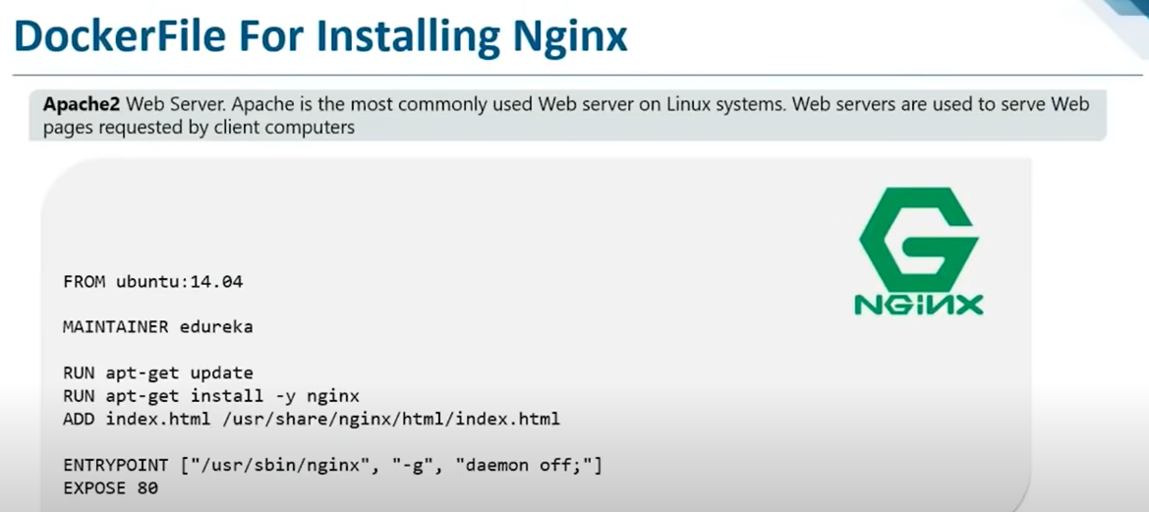

Create one index.html file to show

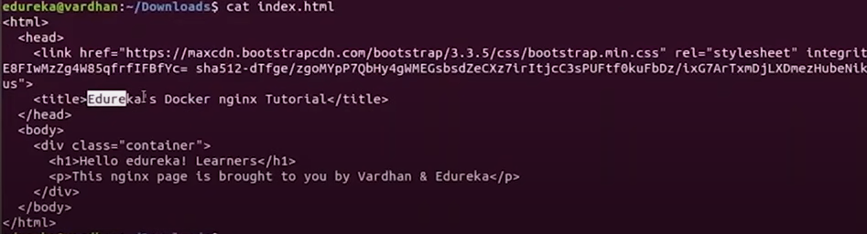

Docker build -t nginximage .

Docker run -p 80:80 –nmae:APP2 nginximage

Docker ps

Docker stop containerid

Commonly Used Docker commands:

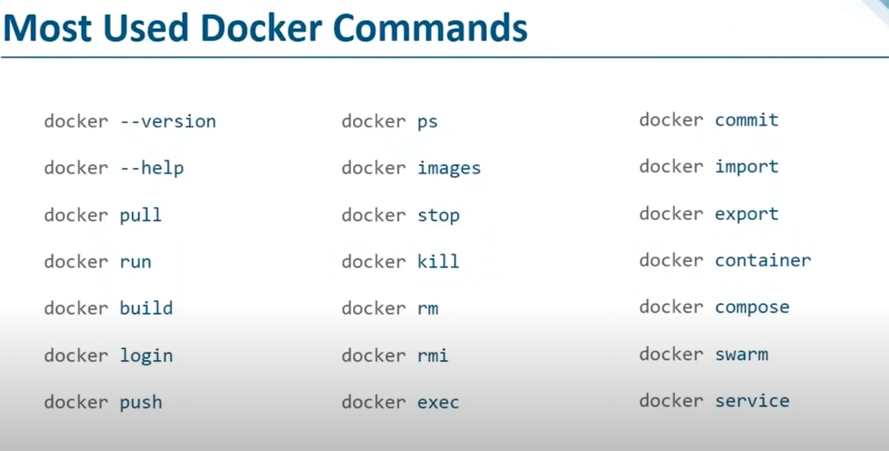

Explain each and everything>

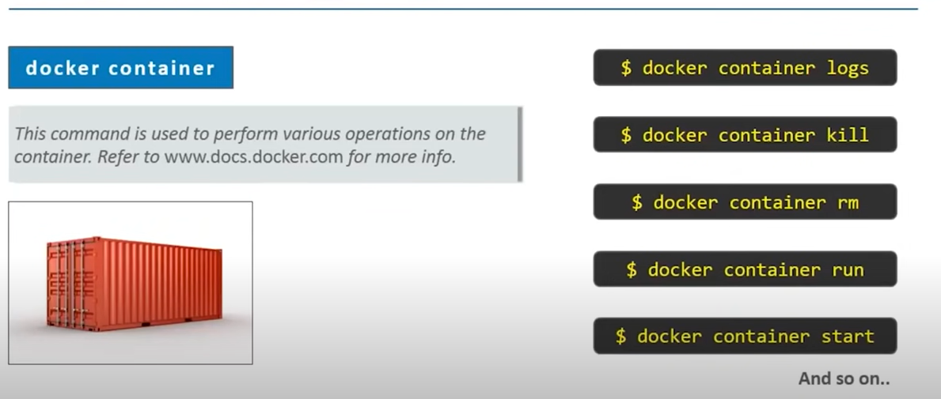

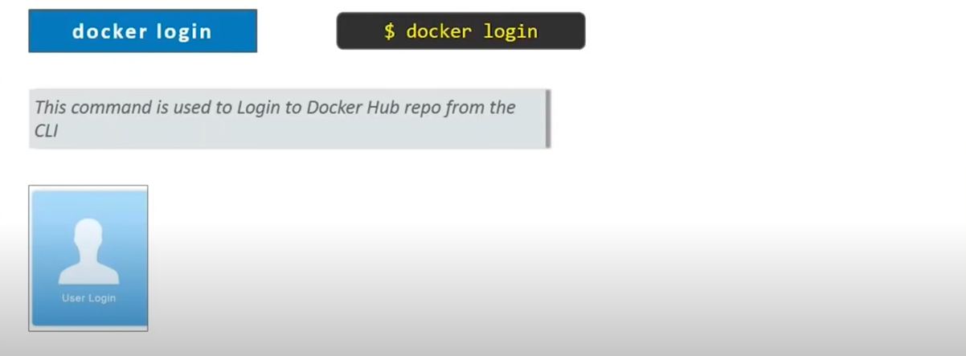

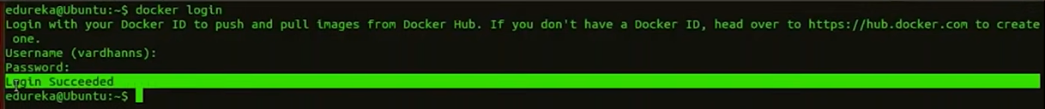

Docker images

Docker tag imagename Anvith/imagename

Do docker images

Docker push Anvith/imagename

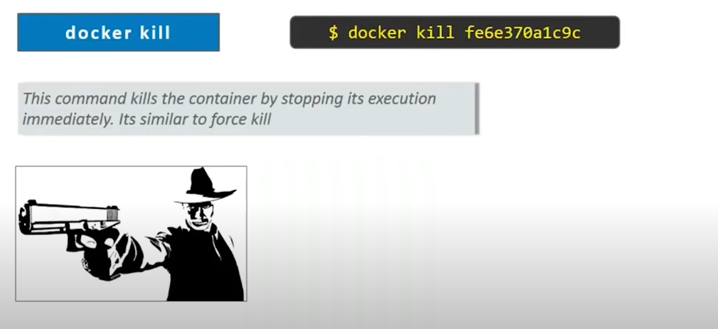

Docker rm containerid

Docker rmi imagename

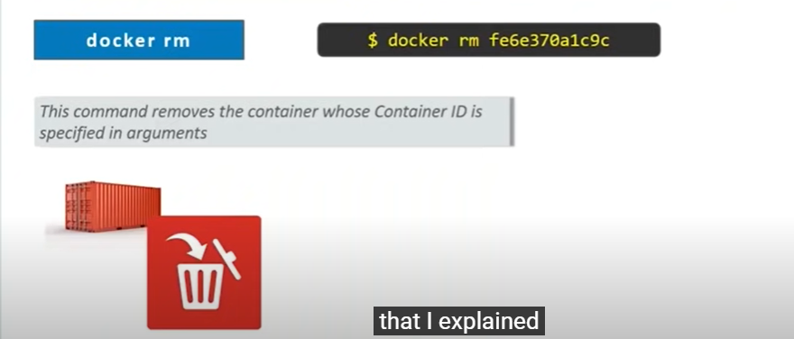

Docker Exec: I means interactive mode

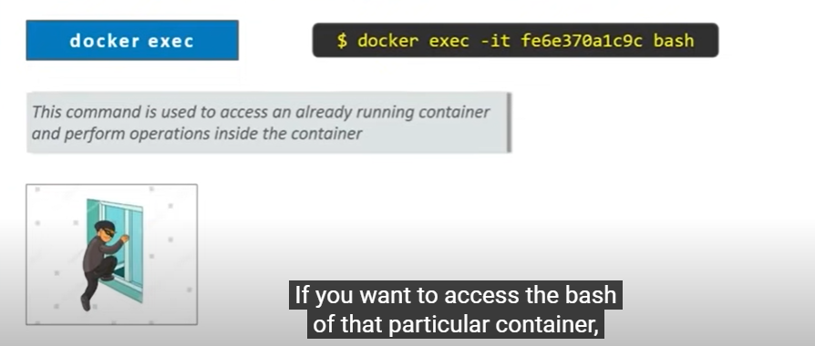

Docker Export: from one place to other.

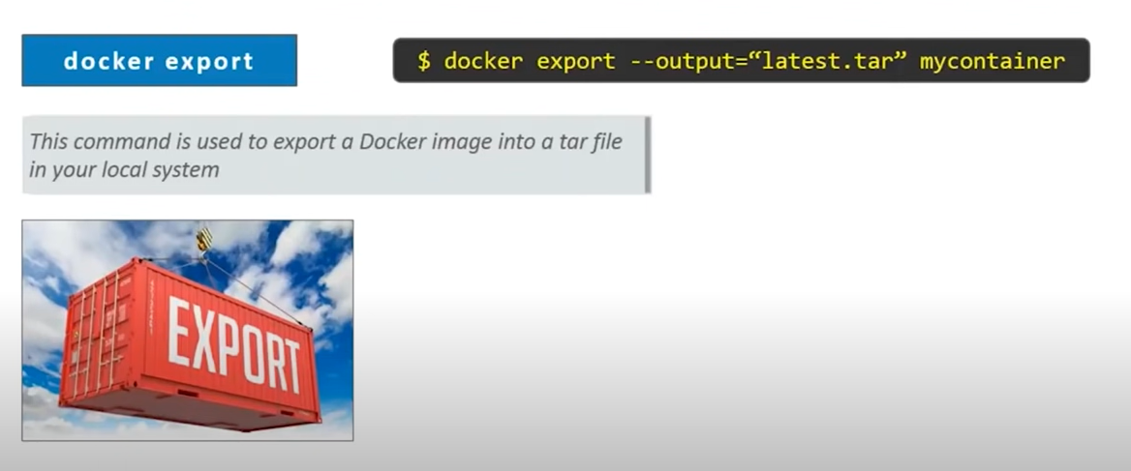

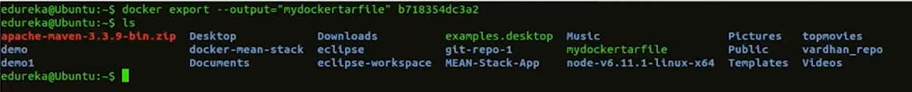

Docker Import: used to import the images shared by developers.

Docker inspect containername

Docker logs containerid

Docker system prune -a

Docker run -v /data:/var/lib/mysql –name mysqldb -e MYSQL_ROOT_PASSWORD=root -d mysql

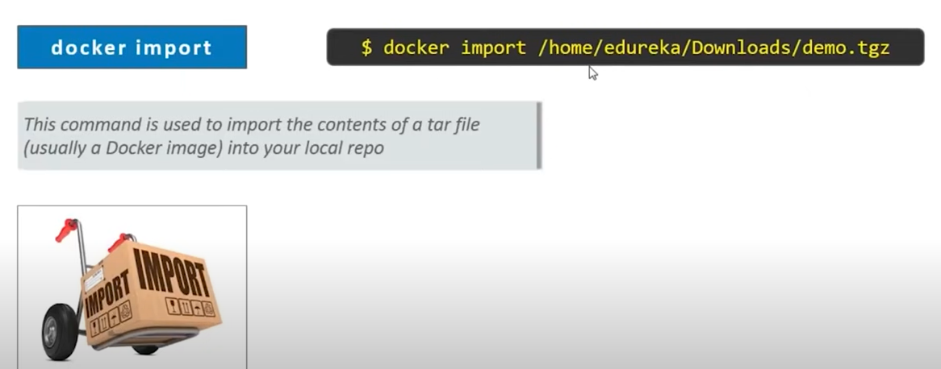

Docker Compose:

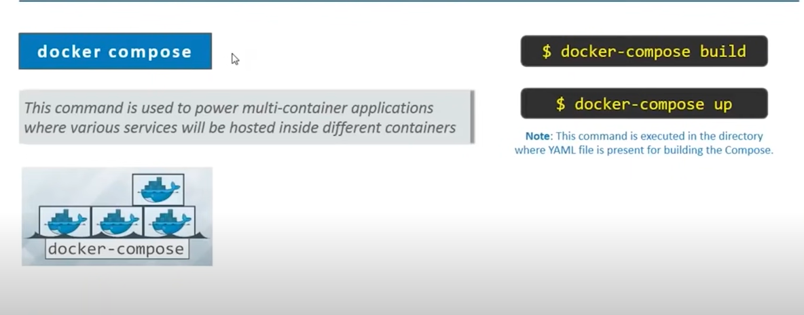

**Docker volumes**

[Volumes](https://docs.docker.com/storage/volumes/) are a great mechanism for adding a data persisting layer in your Docker containers, especially for a situation where you need to persist data after shutting down your containers.

Docker volumes are completely handled by Docker itself and therefore independent of both your directory structure and the OS of the host machine. When you use a volume, a new directory is created within Docker’s storage directory on the host machine, and Docker manages that directory’s contents.

**Benefits of using volumes**

In Docker volumes, storage is not coupled to the lifecycle of the container, but instead exists outside of it. This has many benefits.

For one, you can kill your container as many times as you want and still have your data persisted. It’s also easy to reuse storage in multiple containers; for example, one container writes to the storage while another reads from it.

https://www.baeldung.com/linux/assign-port-docker-container#:~:text=Port%20mapping%20is%20used%20to,redirected%20into%20the%20Docker%20container.

Docker Volumes:

docker volumes are used to persist the data across the lifetime of a container

WHen u delete container data everything you will loose so if u map the data of container to outside so storage will be there on host also even if docker

container gets deleted.

docker run -it -v /home/ubuntu/anvith:/app -d ubuntu this will map ouside location with inside(left outside:)

then go inside container and then check /apps u will find 2 files

here go to anvith folder in one more duplicate session and then create one dummy file then here in container do ls u will find that dummy file)

here it is bind mount - bcz same mount volume i cant find in windows OS right so this is not fair. we have to create volumes for this.

docker volume create test

docker volume ls

docker run -it --mount source=test,target-/app -d ubuntu --> touch 2 files

same way create one more container using above method and then do ls all files u will get here. these volumes are shared. this volume is automatically

handled by docker engine.

now do for our docker file

docker volume create apache

docker run -it --mount source=apache,target=/var/www/html -d new_dockerfile

docker exec -it containerid /bash

cd /var/www/html do ls u will find files same will be found in apache volume

here create one more container using ubuntu image

===============================================================================

**Docker FILE**

MKDIR Anvith

cd Anvith

Vi DOckerfile

FROM

ADD

Run

CMD

ENTRYpoint

ENV

**From** keyword is used to define the base image,on which we will be building

**ADD** keyword is used to add files to container being built.

**Run** keyword is used to add layers to the base image, by installing the components,each run statement adds new layer to docker image

**CMD** keyword is used to run commands on start of the container. These commands run only when there is no argument specified while running the container

**ENTRYPOINT** command i used strictly run commands the moment the container initializes. diff b/w cmd and ENTRYpoint is EP will run irrespective of the fact whether argument is specified or not

**ENV** keyword is used to define environment variables in container run time

here entrypoint will run the apache as soon as container created in browser

ex:

From UBUNTU

RUN apt-get update

RUN apt-get -y install apache2

ADD . /var/www/html

ENTRYPOINT apchectl -D FOREGROUND (CMD apchectl -D FOREGROUND

ENV name Devops Cloudtechnology

================================================================================================================

vi 1.html

<html>

<title>Hello world</title>

<body>

<h1>Hello from cloudtech</h1>

</body>

</html>

==============================================================================================================

once done do this command

docker build . -t new_dockerfile

to change user setting do ( sudo usermod -aG docker $USER ) do relogin

docker run -it -p 84:80 -d new_dockerfile /bin/bash

now do docker ps

if container is running then search in browser and do ip:84/1.html

go and check /var/www/html html files will be there

then do echo $name

============================================================================================================

**Docker Volumes:**

docker volumes are used to persist the data across the lifetime of a container

WHen u delete container data everything you will loose so if u map the data of container to outside so storage will be there on host also even if docker

container gets deleted.

docker run -it -v /home/ubuntu/anvith:/app -d ubuntu this will map ouside location with inside(left outside:)

then go inside container and then check /apps u will find 2 files

here go to anvith folder in one more duplicate session and then create one dummy file then here in container do ls u will find that dummy file)

here it is bind mount - bcz same mount volume i cant find in windows OS right so this is not fair. we have to create volumes for this.

docker volume create test

docker volume ls

docker run -it --mount source=test,target-/app -d ubuntu --> touch 2 files

same way create one more container using above method and then do ls all files u will get here. these volumes are shared. this volume is automatically

handled by docker engine.

now do for our docker file

docker volume create apache

docker run -it --mount source=apache,target=/var/www/html -d new_dockerfile

docker exec -it containerid /bash

cd /var/www/html do ls u will find files same will be found in apache volume

here create one more container using ubuntu image

<https://www.baeldung.com/linux/assign-port-docker-container#:~:text=Port%20mapping%20is%20used%20to,redirected%20into%20the%20Docker%20container>

============================================================================================================================

Microservices: is a s/w development architectural style that structures an application as a collection of loosely coupled services

monolithic give filpkart example. single componential change affect whole application.

--------------------------------------------------------------------------------------------------------------------------------

**Docker compose:**

its a tools for defining and running multi container applications. with compose use YAML file to configure your app service. then with a single

command you can create and start all the services from your configuration.

just run docker-compose up and docker compose starts and run your entire app.

Compose installation:

sudo apt-get update

sudo apt-get install docker-compose-plugin

mkdir compose

cd compose

vi wordpress.yaml(u will get code from docs.docker.com

mv wordpress.yaml to docker-compose.yaml

docker-compose.yaml in image in pc

docker-compose --version

if its not there install it using google commands

docker-compose up -d

copy ip in browser and use ip:8000 website is up and running do login and see

do docker PS u will get multiple containers

if u delete this wordpress everything gone so to comeup with this we have docker swarm

For more info about code:https://github.com/docker/awesome-compose/tree/master/official-documentation-samples/wordpress/

==================================================================================================================================

**DOCKER SWARM:** when we launch multiple containers to monitor the health of the container. if u delete container by mistake then whole server gone.

the health of the container is monitored by docker itself.

its is a clustering and scheduling tool for docker container.

if multiple containers are hosted on same m/c then what happens if machine goes down? so they will create containers on diff machines.

leader --> worker node1 -->node2 --> node 3(distributed architecture)

Creating a docker swarm cluster:

we have master already which docker installed

Create one slave name it as worker node same ubuntu AMI

in master node do

docker swarm init --advertise-addr=private ip of master node

now login to worker node

do sudo apt-get update

sudo apt-get install docker.io

now docker installed and now do sudo (copy the join line output of docker swarm init --advertise-addr=private ip of master node command)

also change security grp to all traffic

do docker node ls on master you will find 2 nodes

if you want to leave the cluster then u can do sudo docker swarm leave

wait for some time till its health check happen then it will go down

to leave master also from swarm then do docker swarm leave --force

also use docker swarm join --token tokenaddress

For more info: https://docs.docker.com/engine/swarm/swarm-tutorial/create-swarm/

---------------------------------------------------------------------------------------

**launch apps on swarm:**

containers on the cluster are deployed using services on docker swarm.

Service is long running docker container that can be deployed to any node worker.

docker service create --name httpd --replicas 5 -p 83:80 httpd

docker service ls

now 5 conatiners running

take master ip:83 and also workernode ip:83 both u can access

docker ps on master and docker ps on node

now do sudo docker rm -f $(docker ps -a -q) on master and also on node

still u are able to access bcz of autoscaling

docker service scale httpd=2 (it will scale down the container)

docker service ls

**Docker Network:**

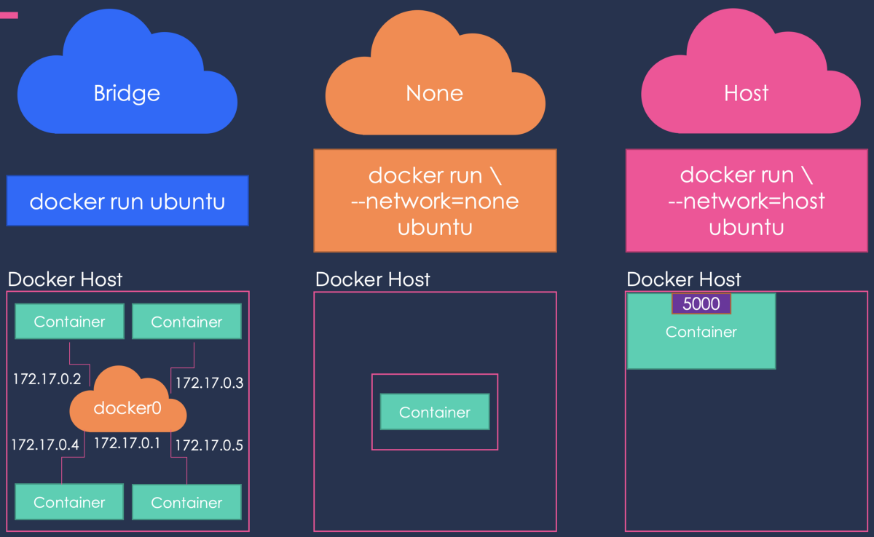

Network Drivers

Docker supports networking for its containers via network drivers. These drivers have several network drivers.

In this article, we will be discussing how to connect your containers with suitable network drivers. The network drivers used in Docker are below:

* Bridge
* Host
* None
* Overlay
* Macvlan

Bridge

* It is a private default network created on the host
* Containers linked to this network have an internal IP address through which they communicate with each other easily
* The Docker server (daemon) creates a virtual ethernet bridge docker0 that operates automatically, by delivering packets among various network interfaces
* These are widely used when applications are executed in a standalone container

### Host

* It is a public network
* It utilizes the host’s IP address and TCP port space to display the services running inside the container
* It effectively disables network isolation between the docker host and the docker containers, which means using this network driver a user will be unable to run multiple containers on the same host

### None

* In this network driver, the Docker containers will neither have any access to external networks nor will it be able to communicate with other containers
* This option is used when a user wants to disable the networking access to a container
* In simple terms, None is called a loopback interface, which means it has no external network interfaces

### Overlay

* This is utilized for creating an internal private network to the Docker nodes in the [Docker swarm](https://www.simplilearn.com/tutorials/docker-tutorial/docker-swarm) cluster
* Note: Docker Swarm is a service for containers which facilitates developer teams to build and manage a cluster of swarm nodes within the Docker platform
* It is an important network driver in Docker networking. It helps in providing the interaction between the stand-alone container and the Docker swarm service

### Macvlan

* It simplifies the communication process between containers
* This network assigns a MAC address to the Docker container. With this Mac address, the Docker server (daemon) routes the network traffic to a router
* Note: Docker Daemon is a server which interacts with the operating system and performs all kind of services
* It is suitable when a user wants to directly connect the container to the physical network rather than the Docker host

## Listing All Docker Networks

docker network ls

## Inspecting a Docker network

docker network inspect networkname

### Example

sudo docker network inspect bridge

Now let’s run a container and see what happens when we inspect the network again. Let’s spin up an Ubuntu container with the following command −

sudo docker run –it ubuntu:latest /bin/bash

Now if we inspect our network name via the following command, you will now see that the container is attached to the bridge.

sudo docker network inspect bridge

Creating Your Own New Network

One can create a network in Docker before launching containers. This can be done with the following command −

Syntax

docker network create –-driver drivername name

Options

* **drivername** − This is the name used for the network driver.
* **name** − This is the name given to the network.

Return Value

The command will output the long ID for the new network.

Example

sudo docker network create –-driver bridge new_nw

Output

The output of the above command is shown below −

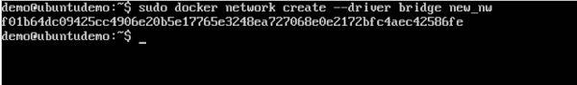

You can now attach the new network when launching the container. So let’s spin up an Ubuntu container with the following command −

sudo docker run –it –network=new_nw ubuntu:latest /bin/bash

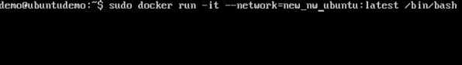

And now when you inspect the network via the following command, you will see the container attached to the network.

sudo docker network inspect new_nw

